





Did you know that over 115 million kilograms of pizza are consumed daily worldwide??? (Well according to Wikipedio onyway...)

Danny was scrolling through his Instagram feed when something really caught his eye - “80s Retro Styling and Pizza Is The Future!”

Danny was sole! on the ic!ea, but he knew that pizza alone was not going to help him get seec! lunching to expanc! his new Pizza Empire - so he hoc! one more genius ic!ea to combine with it - he was going to Uberize it - one! so Pizza Runner was launches!!

Danny started by recruiting “runners” to deliver fresh pizza from Pizza Runner Headquarters (otherwise known as Danny's kouse) and also maxed out his credit card to pay freelance developers to build a mobile app to accept orders from customers.



 



Danny, a data scientist with a few years of experience, knew that data collection was essential for his business's growth. He created an entity relationship diagram (ERD) for his database design, but he needed help cleaning the data and applying basic calculations. This would allow him to better direct his runners and optimize Pizza Runner's operations.

I am Arckis Rudro, a data analyst. I will use my SQL skills to help Danny make data-driven decisions. I will answer his questions and help him clean and analyze his data. This will allow Danny to make better decisions about how to run his business.

Entity Relationship Diagram

runner orders

pi z z a n am es

customer orders

p1zza rec i pes

runners





 

runners:

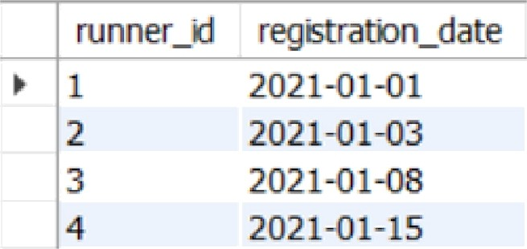The runners table shows the registration date for each new runner.

|  |  |
| --- | --- |
| runner_d | reqstmton_date |
| y 1 | 2021-01-01 |
| 2 | 2021-01-03 |
| 3 | 2021-01-08 |
| 4 | 2021-01-15 |

customer_orders:

Customer pizza orders are captured in the customer_orders fable with 1 row for each individual pizza that is part of the order.

The pizzo_id relates to the type of pizza which was ordered whilst the exclusions are the ingredient_id values tkat should be removed from the pizza and the extras are the ingredient_id values that need to be added to the pizza.

hJote that customers can order multiple pizzas in a single order with varying exclusions and extras values even if the pizza is the same type!





|  |  |  |  |  |  |
| --- | --- | --- | --- | --- | --- |
| > 1 | 101 | 1 |  |  | 2020-01-01 18:05:02 |
| z | 1 | 1 |  |  | 2O20-0i-0› i9:0»:S2 |
| 3 | 102 | 1 |  |  | 2020-01-02 23:51:Z3 |
| 3 | 102 | 2 |  |  | 2020-01-02 23:51:23 |
| 4 | 103 | 1 | 4 |  | 20Z0-01-04 13:23:46 |
| 4 | 103 | 1 | 4 |  | 2020-01-04 13:23:46 |
| 4 | 103 | 2 | 4 |  | 2020-01-04 13:23:46 |
| 5 | 104 | 1 | rxM | 1 | 2820•01-0821:00:29 |
| 6 | 101 | 2 | rnil | Mž | 2020-01-0821:03:13 |
| 7 | 1DS | 2 | rc5 | 1 | 202O•O1-DB2I:20:29 |
| B | 1D2 | 1 | raJI | rx5 | 2O20-01-0923:54:33 |
| 9 | lDD | 1 | 4 | 1,5 | 29]{EO}-*O II:2Z:59 |
| 10 | 1Q4 | 1 | riM | nuf | 2020@111 1g34:49 |
| 10 | 104 | 1 | 2, 6 | 1, 4 | 2O20KR1I IB:34:49 |

runners_orders:

After each order are received througk the system - they are assigned to a runner - however not all orders are fully completed and can be canceled by the restaurant or the customer.

The pickup_time is the timestamp at which the runner arrives at the Pizza Runner headquarters to pick up the freskly cooked pizzas. The distance and duration fields are related to how far and long the runner had to travel to deliver the order to the respective customer.

|  |  |  |  |  |  |
| --- | --- | --- | --- | --- | --- |
| order_g | runner_d | picXup_tme | dBta›ce | durattxi | caxzšatx›o |
| * 1 | 1 | 2020-01-01 18:15:34 | 20Xm | 32 mčxites |  |
| 2 | 1 | 2020-01-01 19:10:54 | 20Xm | 27 m¥¥Jtes |  |
| 3 | 1 | 2020-01-03 iXl:12:37 | 13.4km | 20 mčs | " |
| 4 | 2 | 2020-01-04 13:S3:03 | 23.4 | 40 | " |
| S  6 | Z  3 | 2020-01-08 21:10:57  nul | 10  nul | 1S  nul | Reslaurant CaxeBtc›n |
| 7 | 2 | 2020-0 -08 2›.30:45 | 25zm | 2S | ixil |
| 8 | 2 | 2020-o1-1o fXf:1S:o2 | 23.4 km | 15 rrl¥x/te | rxil |
| 9 | 2 | nul | nul | nul | Cust‹xrw Caixzgalxxi |
| t0 | 1 | 20Zo-o1-t1 18:s0:20 | t0bzi | l0rraMes | rng |

pizzo_nomes:

At the moment - Pizza Runner only kos 2 pizzos available the Meot Lovers or Vegetorion!

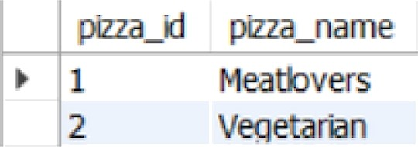

pizza recipes:

Each pizza id has a standard set of toppings thot ore used as port of the pizza recipe.

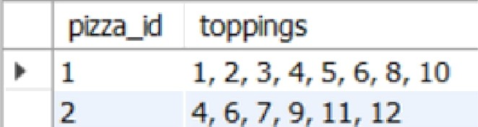

—

k 1

2

topfXnqs

1, 2, 3, 4, 5, 6, 8, 10

4, 6, 7, 9, 11, 12

pizzo_toppings:

This table contains all of the topping_nome values with their corresponc!ing topping_id value.

|  |  |  |
| --- | --- | --- |
|  | tqppng_d | topp$›g_name |
| › | 1 | Bacon |
|  | 2 | x |
|  | 4 | Cheese |
|  | 5 | Clken |
|  | 7 | Orñxis |
|  | 8 |  |
|  | 9 | Peppers |
|  | 10 | S arrg |
|  | 11 | Tomatc›es |
|  | 12 | Tomato Sauce |

 

Data Cleaning was a bit tricky for this pro|ect task. I have hanc!lec! the missing and null values of tables (i.e., runner_orders and customer_orders) in orc!er to clean the c!ata.

customer_orders:

|  |  |  |  |  |  |  |
| --- | --- | --- | --- | --- | --- | --- |
| ordered | cussxner | ¥i | pizza d | excusbm | extras |  |
| r 1 | 101 |  | 1 |  |  | 2920—01-O1 18:05:02 |
| 2 | 1 |  | 1 |  |  | 2020-01-01 19:00:52 |
| 3 | 102 |  | 1 |  |  | 2020-01-02 23:51:23 |
| 3 | 102 |  | 2 |  |  | 2020-01-02 23:51:23 |
| 4 | 1OZ |  | 1 | 4 |  | 2020-01-iH 13:23:46 |
| 4 | 103 |  | 1 | 4 |  | ?0?0-01-04 13.23:46 |
| 4 | 10Z |  | 2 | 4 |  | 2020-01-04 13:23:46 |
| 5 | 104 |  | 1 | nul |  | 2020-01•08 21:00:29 |
| 6 | 101 |  | 2 | nul | nul | 202P-01-08 21:03:13 |
| 7 | 105 |  | 2 | nul |  | 202001-08 21:20:29 |
| s | 102 |  | 1 | nul | nul | 2020-01-09 23:Sd:33 |
| 9 | 103 |  | 1 | 4 | 1, 5 | 2020-01-10 11:22:59 |
| 10 | 104 |  | 1 | nul | nul | 2020-01-11 18:34:49 |
| 10 | 104 |  | 1 | 2, 6 | 1, 4 | 2020-01-11 18:H:49 |

upoate customer orders am€ exclusions : null rheme exclusions : ’ ';

update custornen_or’ders set exe1us 1ons a null

where etclusioms = "null”;

update customer_orders set ext ras - nulL whoro extras : '';

updmtc customer_orders set extras : null whcw• extras = ”null“g

order_d Dstorr›er_d $¥zza_d exd ans extras

> 1 101 1 " "

order_tzne

202001 01 18:05:02



|  |  |  |  |  |  |
| --- | --- | --- | --- | --- | --- |
| 2 | I01 | 1 |  |  | 2020-01-01 19:00:52 |
| 3 | 102 | 1 |  |  | 2020-0t-02 23:51:23 |
| 3 | io2 | 2 |  |  | 2020-01-02 Z3:51:23 |
| 4 | 103 | 1 |  |  | 202&-01-04 13:23:46 |
| 4 | 1D3 | 1 |  |  | 2020-01-0d 13:23:46 |
| 4 | 103 | 2 |  |  | 2020-£i1-04 13:23:46 |
| 5 | 1.04 | 1 |  |  | 202001-08 21:00:29 |
| 6 | 101 | Z |  |  | Z0Z0-O I-08 21:03:13 |
| 7 | tO5 | 2 | " |  | 2020-0\-08 22:20:29 |
| 8 | 1D2 | 1 |  |  | 202fh'01-09 23:54:33 |
| 9 | 103 | i | 4 |  | 2020-£i1-10 11:22:59 |
| 10 | 104 | 1 |  |  | 202D-01-11 18:34:49 |
| 10 | l0'l | 1 | 2. fi | 1. 9 | 2020-£i1-LI 18:3't:49 |





|  |  |  |  |  |  |  |
| --- | --- | --- | --- | --- | --- | --- |
| before  runner_orders: | | | | | | |
|  | order_cI | runner_d | piCkup_ome | datance |  |  |
| » | I | I | 2020-01-0118:15:34 | 20km | 32minutes |  |
|  | 2 | 1 | 2020-01-0119:l0:S4 | 20km | 27 Minutes |  |
|  | 3 | 1 | 202O-0I-0300:lZ:37 | 13.4km | 20mins |  |
|  | 4 | 2 | 2020—O1—04 13:53:o3 | 23.4 | 40 |  |
|  | S | 3 | z0z0—0 1 08 21: 10:57 | 10 | 15 |  |
|  | 6 | 3 | nul | nut | n‹uI | Restaurant Cancetaton |
|  | 7 | 2 | 2020-0 1-08 21:30:45 | 25km | 25a | nut |
|  | 8 | 2 | 2020-01-10 00.15:02 | 23.4 km | 15 min‹ute | nul |
|  | 9 | 2 | nul | nul | unul | Customer Cancelaton |
|  | 10 | 1 | 2020-01-11 18:50:2o | 10krn | t0minutes | nul |

upds£ e r•unng'o ander s

*et pickup_tSm'e z null wherv exclusions: "n‹ 1.. ' ;

updo£e nunner_ander r

set distance z nuJi

wherc distance : " l l”;

upds*e punner_orders set duration z nuJl

where duration : "ni‹ll”,

update runner„orders set cancellation : null

where cancellation : "n I ”;

update runne.r_orders set cancellation : null where cancellation : ";



|  |  |  |  |  |  |
| --- | --- | --- | --- | --- | --- |
| order_cI | runner_d | pckup_t?ne | distance | duration | cancetatbn |
| * 1 | 1 | 2020-01-01 18:15:34 | 20 km | 32 mn |  |
| 2 | 1 | 2020-01-01 19:10:54 | 20 km | 27 mn | ” |
| 3 | 1 | 2020-01-03 00:12:37 | 13.4 km | 20 mn |  |
| 4 | 2 | 2020-0l-04 13:53:03 | 23,4 km | 40 mn | ” |
| S | 3 | 2020 01-08 21:1O:S7 | 10 km | IS mn | ” |
| 6 | 3 | ” | ” | ” | Restaurant Cancetation |
| 7 | 2 | 2020 01 08 21:30:4S | 2S km | 2S mn | ” |
| 8 | 2 | 2020-01-10 00:15:02 | 23.4 km | l5 mn |  |
| 9 | 2 |  | ” | ” | Customer Cance0at tn |
|  | 1 | zozo-of-11 IB:so:zo | to kr» | to mn |  |





This case study has LOTS of questions - they are broken up by area of focus including:

* Pizza Metrics
* Runner and Customer Experience
* Ingredient Optimisation
* Pricing and Ratings

Each of the following case stucly questions can be answered using a single SQL statement.



 

1. How mony pizzas were ordered?



* 1. • se1ect count(•) as tata1_p1zzas_ordered
  2. fw<xe custoner_or•dersy

3

4

‹

aaane+u e•a a w c«s

1. How mony unique customer orders were mode?



* 1. • salect count (d€at£nct custo‹aer‘_1d) aa tota1_custoaer s
  2. from custofeer’_ordersy

4



1. How mony successful orders were delivered by each runner?



* 1. • select runner_1d count(^} as sueces sfu1_de1lvered
  2. from r'unner_order's
  3. where cance1 fat aon is nulE



runner d

1. How mony of each type of pizza was delivered?
   1. • select p1zza na4›e, coun t( *) as pt zza del 1vered
   2. froe custozser_orders c
   3. 1aft •joln p1z z a_nazses p usxnjj(p1z za_1d)

d wh•r• order_id zn (

**salact** order_1d

fr•m pi z z a_runner - runner_onders wh•r• cance11at:ton 1s null)

8 group by 2 j



### How mony Vegetarian and Meotlovers were ordered by each customer?

e r r D u m ‹•›• - ” x < a tm e

1. • sa1rct customer_id pi z za_name count (*) as pi z za_o dered
2. f'rom custoeer_orders c
3. joln pt z za_naues p us1ng(pt zza„1d}
4. group by 1 2 w1th rollup

2 hav1ng p1z z a_naae ts not nuSI j

|  |  |  |
| --- | --- | --- |
| * tOt | ueatbvers | 2 |
| 101 | vegetarian | l |
| 102 | l4eatbvers | 2 |
| 10Z | ve9etarBn | l |
| 103 | vegetarian  vegetarian | i  i |

1. What was the maximum number of pizzas delivered in a single order?

I • — wit h del1vered as ‹

1. ceJect order id count( *) as pizza de1 ivered
2. from cust omer_orders
3. whare order’_1d 1n (



6

7

1. group by 1}

sclcct order_Sd

from pizza_runner.runner orders whmrm cancellation iz null)

1. select max(p1zza_de1ivered) as max_pi zza„de1free IB froe del1vered j



* 3

1. For each customer, how mony delivered pizzas had at least 1 change and how mony had no changes?



* 1. • ca 2ack custoaer_id,
  2. sum(<ae• uh•n exe1us1ons Sa nu21 and extras 1s null then 1 e1c+ 6 and) a s no_changes
  3. sum(caae when {exclusions I.a nu'I1 and extras Ie not null) or

(exe lus i ones £« no' null and extras 1> null) or

1. {exe3usSons L• n•t null •nd extras 1• n-I nu12J h•n 1 •1•• 8 and) •• at1ee st_one_change
2. »*cr• order_id *u (



9

10

o•Joct order id

* ••' pit z+_ruaaer . naae.»_oWe»s

wh•r• concell^tiOu £m null)



1. How mony pizzas were delivered thot had both exclusions and extras?



* 1. • se2act suo{casa when exclusions Le nod null and extres ta nod nu13 then 1 end) aa no of lzzes
  2. fraei custc›a›er_orders
  3. - uhar• om;Ier_1d In (

celact order_id

5 fr oo pt zzap.runner. runner_orders wh are caneaLI at hon be null)



1. What was the total volume of pizzas ordered for each hour of the day?



3 • **selact hou¥•(order_ti«›e)** aa **hour_of_dey** count ( *) •a np_of_pi zzgs

1. fz•om cust olae r' order•s
2. gr'oup b'y 1 or'dar by 1j

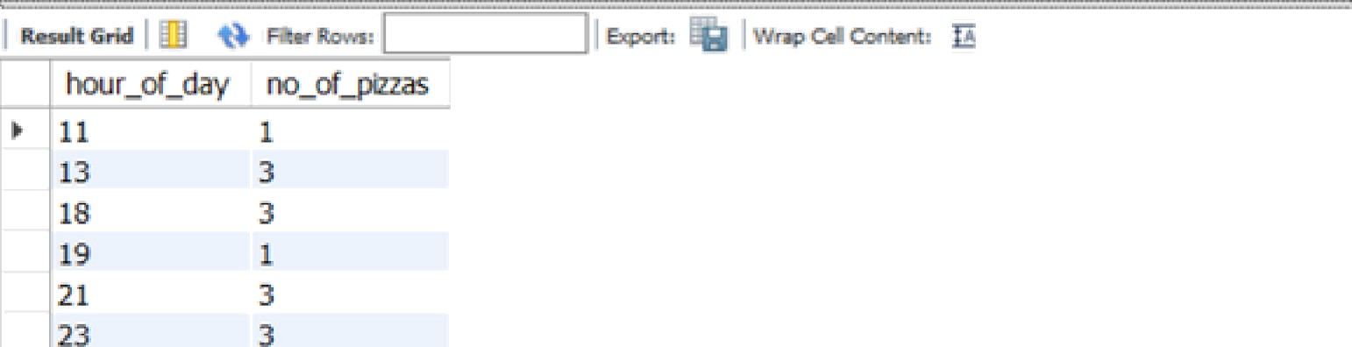

JO. What was the volume of orders for each day of the week?



1. • aa1act dayofweek(order_t1me) •s day_nun,
2. ayname(onder_t1ne) as day_of„ueek, count(*) aa no_of_p1zzas

ñ front custoner_orders





|  |  |  |
| --- | --- | --- |
| day_num | day_of_week | no_0f_pIzzas |
| ›s 4 | WedresdaV | 5 |
| ;! 5 | Thursday | 3 |
| ’! 7 | SzgzJrday | 5 |

INSIGHTS GATHERED

* A total of 14 pizzas were ordered.
* A total of 5 unique customers ordered pizzas.
* The number of successful orders was eight with which Avnner I has the fiigfies/ number of successful orders delivered.
* Meatlovers lype of pizza was sold nine unifs whereas Vegetarian was

sold three units.

* In a single order, the *maximum* number of pizzas delivered was three.
* One single pizza was delivered that kad botk exclusions and extras.
* Wednesday has delivered the highest number of pizzas.



1. How mony runners signed up for each 1 week period? (i.e. week starts

## 202J -OJ -OJ)

* 1. 8 zalact weeko fyea n(r•eg1stret?on_dete + ñnt•rva1 1 u••k) •a ueek_nun count {8 ) ao runn.ers_szgned
  2. from runners



weeIt_num

1. What was the average time in minutes it took for each runner to arrive at the Pizza Runner HQ to pickup the order?
   1. * ”-'” ulth avgt1•e aa (
   2. zeI•ct d1ztlnct r •order 1d r • runnei _id
   3. **1-»t•mpd1ff(nSnut•** or^der_txne p1ckup_t*zae) •s m;tnwtes
   4. fz•om runner_orders r
   5. 1nn•r yoln custoner_orders c using(or'der_*d)
   6. vshere cance1tation. 1s null)
   7. select runner_1d , round(avg(n1nutes}) as average_t ifoe_n1nutes
   8. f'ron avgt1•e



1. Is there any relationship between the number of pizzas and how long the order takes to prepare?
   1. • select p1zz a_count round(avg(t1fae_requ1red}) a.s avg_t1me„requ1red
   2. ' re«t ( select d't st1nct r .order_1d,
   3. t1atestampd1ff(m:Lnute, order_t1›me, pt ckup_t lose) as I 1rse_requ1red,
   4. count ( • ) over(pai•t1t1on by order_id) as pt zza_count
   5. froa runner_orders r
   6. Snner join custoaer_ord!ers c us1ng(order_1d )
   7. where cance11at ton xs null) as re1at ton
   8. group by J y

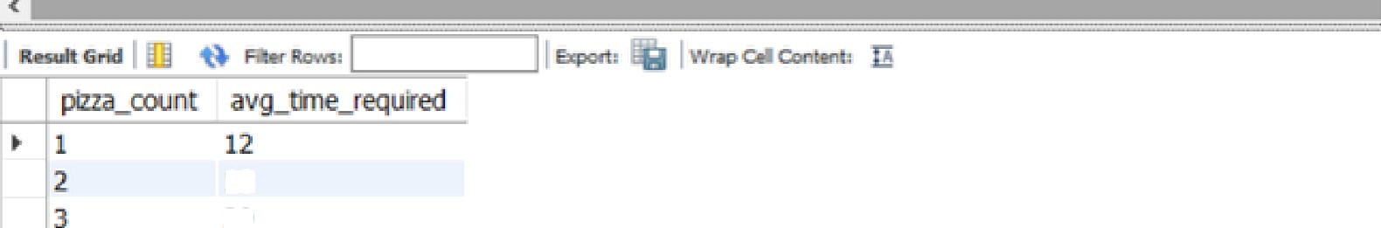

1. What was the average distance travelled for each customer?



* 1. • select cust oaer_źd sound( avg{dž st am e) , 1) as avg_dż stance
  2. runner_orders r
  3. jożn ć ust omer'_orders c us1njj(or'der_1d)
  4. where d1st anCe żs not null
  5. group by 1 order by 1j

|  |  |
| --- | --- |
| so 0l ‘t¥  aJstomer_Ò | :  avg_dòtanœ |
| D 101 | 20 |
| 102 | 16.7 |
| 103 | 23.4 |
| 104 | 10 |
| 105 | 25 |

1. What was the difference between the longest and shortest delivery times for all orders?



* 1. • select max(duration) as longest_delivery_times,
  2. rin(duration) as shortest delivery_time, (mcx(duration) (duration)) as difference

4 from runner_orders;

detvery_trnes shortest_dØvery'_tme deference

> 40 mh 10 rnh 30

1. What was the average speed for each runner for each delivery and do you notice any trend for these values?



* 1. • — u1th average as

a•1•ct order_śd, runner_id›

round( (distence * Ö0 ) /durøtion, 2 ) •ø speed_kmph

from r‘unne r_o nde s

whorc cancellation io mull

b 

”ø nuund(avg( speed_kmph) average j

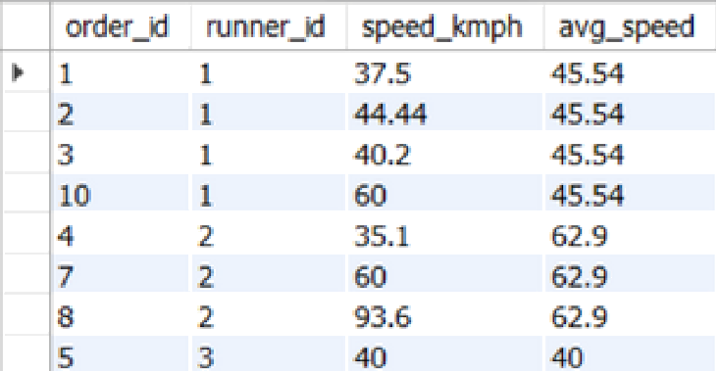œ+i ra+r . : wt«o cø ac- G

|  |  |  |  |
| --- | --- | --- | --- |
| *oÆef_”b* | rtmrier_Õ | speed_kmph | avg_speed |
| *' 1 | 1 | 37.5 | 45.54 |
| 2 | 1 | 4s.44 | 4S.S4 |
| Z | 1 | 40.2 | 45.54 |
| L0 | 1 | 60 | 45.S4 |
| 4 | 2 | 35.1 | 62.9 |
|  |  | 93.6 | 62.9 |

1. What is the successful delivery percentage for each runner?



with percentage zm C n•l•ct xnner_id,

sum(c^cu ‹Whu« caacelJaCion ia nwll th•n 1 cln• 0 •nd) ^s succ#ssCul delivery, count(°) zs total_ord•r

" from nunner_ordero

6 6"°°P*Y *l

C concat (round( (succassfu1_da11vary*100/tota1_order) ,2 } " g" ) as soccas sfu1_daJ:ivary_prcnt

9 A rots percentage j



2 75XXl %

INSIGHTS GATHERED

* In the first week, there is the *highest* number of runners were signed.
* Pizza Runner 2 takes a *longer* time whereas Pizza Runner 3 takes the

*shortest* time to arrive at Pizza HQ to pick up the order.

* The relationship between the number of pizzas and the time required to prepare is positively correlated.
* The difference between the *longest* and *shortest* delivery times for all orders was 30 minutes.
* Pizza Runner 1 has the *highest* successful delivery percentage.



*So, to* gather information about the ingredients we need to transform the tables (i.e., pizzo_recipes and customer_orders) and make them as a virtual table (VIEW based on the result-set of an SQL statement.

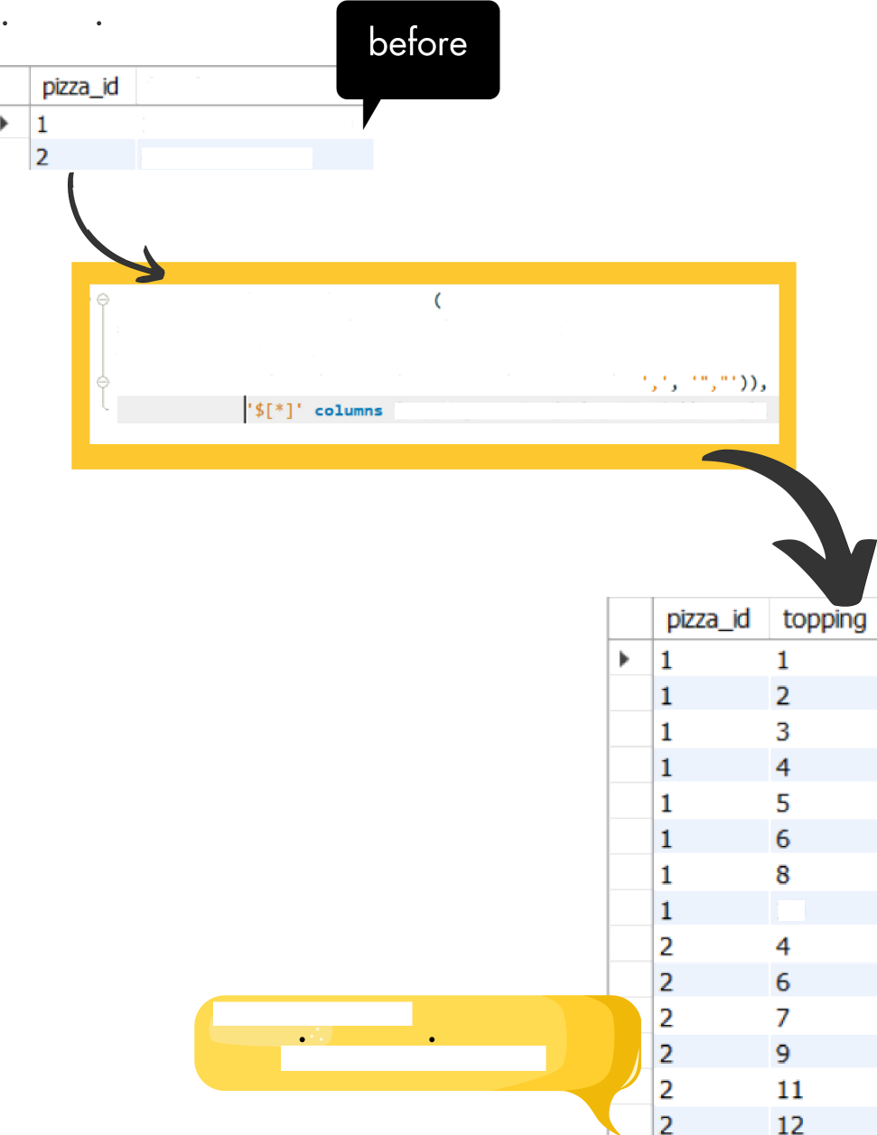

pizzo_recipes:

1, 2,3, 4, 5, 6, 8, 10

4, 6, 7, 9, 11, 12

z••zt• vi•w pizza_recipe_new z•

re*ect r.pizza_id, trim(j.topping) cs topping

from pizza_recipes r

join j son_tab1e(I r1m( relpface( j son_array( r . toppings},

(topp1ng varchar(se) paCh ' $ ' )) as §} j

10

## e ew as

pizzo_receipe_new

customer_orders:

‘

|  |  |  |  |  |  |
| --- | --- | --- | --- | --- | --- |
| order_d | customer_d | pizza_i1 | exc:hsöns | extras | order üme |
| > 1 | 10J | 1 | ” | ” | 2020-OR-01 18:0 !02 |
| 2 | 10J | 1 |  |  | **2020-01-0t** 19:00:52 |
| 3 | 102 | I |  |  | 2020-01-02 23:51:23 |
| 3 | 102 | 2 |  |  | 2020-01-02 23:51:23 |
| 4 | 103 | 1 | 4 |  | 2020-01-04 13:23:46 |
| 4 | 103 | 1 | 4 |  | 2020-01-04 13:23:46 |
| 4 | 103 | 2 | 4 |  | 2020-01-04 13:23:46 |
| S | i04 | i |  | 1 | 2020-01-08 21:00:29 |
| 6 | 101 | 2 |  |  | 2020-01-08 21:03: f3 |
| 7 | 105 | 2 |  | 1 | 2020-01-08 21:20:29 |
| 8  9 | 102  103 | 1  1 | 4 | i, s | 2020-01—09 23:54:33  2020—OU—10 11:22:59 |
| lo | iß4 | 1 |  |  | 2020-01-11 18:34:49 |

‘

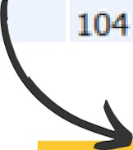10 1 2, 6

1,4

2020-OU-11 18:34:49

create view customer order new a s (

**select** c.onder Id, c . cu st omer_id , c . pi z z a id, I i ’ ( j . excl us ion s) as exc1us i an

t' i'’(k.extras) a& extras, order_time Crom customer_orders c

join j*on_tzble(t’i (rvplzce(json_array(c.exclus*ons), ,', "',” )),

I ’ column* (exclusions vnrchor(-t) path 'S’)) n* j join j*on_tzb1e('' in(replocv(json_array(c.extras), ,’, ')),

S ’]' columns (extras varchar(50) path 'S')) ao

order_Ö customer_cI pcza_<I exclusion extras

r 1 101 1 ” "

order_txne

Z020-01-01 18:05:02

# cusDmer_order_new

|  |  |  |  |  |  |  |
| --- | --- | --- | --- | --- | --- | --- |
|  | 2 | 1 | 1 | ” | ” | 2020-0v0l19:00:S2 |
| 3 | 102 | 1 | ” | ” | ]020I1-0223:51:]3 |
| 3 | 102 | 2 |  |  | 2020-01.0223:S1:23 |
| 4 | 103 | 1 | 4 |  | Z020I1-O4 l3:23:46 |
| 4 | 103 | 1 | 4 |  | 2020-01-04 13:23:46 |
| 4 | 103 | 2 | 4 |  | 2020-01-04 13:23:46 |
| 5 | 104 | 1 | ” | 1 | 2020-01-08 21:00:29 |
| 6 | 101 | 2 | ” | ” | 2020—0I—08 21:03:13 |
| 7 | 105 | 2 |  | 1 | 2020-01-0821:20:29 |
| 8 | 102 | 1 |  |  | 2020-0I -09 23:54:33 |
| 9 | **103** | 1 | 4 | 1 | 2020D1-1011:22:59 |
| 9 | 103 | 1 | 4 | 5 | 2D2O-01 -10 11:22:59 |
| fo | 104 | i |  |  | 2020-01-11 18:34:49 |
| 10 | 104 | 1 | 2 | 1 | 2020-01-11 18:34.49 |
| 10 | 104 | 1 | 2 | 4 | 2020—01—11 18:34:49 |
| 10 | 104 | 1 | 6 | 1 | 2D2D-01-11 18:34:49 |
| 10 | 104 | 1 | 6 | 4 | 2020—01-11 18:34:49 |
| create view as |  |  |  |  |  |  |

1. What ore the standard ingredients for each pizza?



l • selott p2.pizza_ngme,

- ( p 3. to pp i ng_n ame s epo • o I er ' ) o: standard_ingredisnts

from gizza_recipe_new pl

inncr join pizza_names p2 u-mq(pizza_id)

6 inncr join pizza_toppings p3 on p3.toppìng_id = pS.toppìng



pRza name standard +mg edenn

r Meaoovers hon, BBgi Sauce, Beef, Cheese, Chcken., I \u5hroonJs, Pepperoni, SaBmi VeqeCanan Cheese, Mushrooms, Onions, Peooers, Tomatoes, Tomato sauce

### What was the most commonly added extra?



l • select topping_name zs most_commonly_added_extra from pizza toppings

\vhe re t opp i ng_z d - (

select extras

select extras, t(*) zs times_used from customer_order_new

 where extras is not null

group Iby I order by desc limit :)

a s t ) j

 np a q :va ce ccter. r

most commonly added extra

› Bacon

### What was the most common exclusion?



1 - :olecC topping_name s most_common_exc1usion



'.'.'h e we I opp1ng i *d --* (

 :cleut exclusion

so I o ct exc I us ion , ( * } a» I i me s_us ed

from Customer_order_new

:hcrc exclusion i, not null

group b; I o dcr by disc limit l )

Result G nd 

most_common_exctision

› Cheese

1. Generate on order item for each record in the customers orders table in the format of one of the following:
   * Meat Lovers
   * Meat Lovers - Exclude Beef
   * Meat Lovers - Extra Bacon
   * Meat Lovers - Exclude Cheese, Bacon - Extra Mushroom, Peppers.



* + 1. ^ - w1th generate cust order as (
    2. a a fact d1st met con. order_id, con . custooer_id, con . pi zz a_1d ,

* can c at ”Ex c I ude ”, pt. t opping_nene) as exe1us ton

con. extr'as , con.or’der_tzme

from cuStomer_or'der_new con

6 left join pizza_toppings pt

on con. exc1us1on - pt . I opp1n x d

1. se2ect d1st in ct gc . order_1d, gc - cust omer_1d, gc. pt z za_1d,
2. gc . exe1 usion as exe1usion
3. c can c a t ( " E xt r a " J pt - t op ping_n sr›e) ss ext ras gc . rder•_t inc
4. from gener'ate_cust_or’der gc
5. left join p1zza_topp1ngs pt
6. **on gc.extras** pt.topp1ng_1d;)

|  |  |  |  |  |  |
| --- | --- | --- | --- | --- | --- |
| order_xI | custorner_id | péza_d | exctzsbn | extras | order_szie |
| b 1 | 101 | 1 |  |  | 2020-01-01 l8:05:02 |
|  |  |  |  |  | 9030<1Ill9:OO:S2 |
| 3 | lD2 | 1 |  |  | 20Z0-01OZZ3:'51:Z3 |
| 3 | 102 | 2 |  |  | 2020I1T223:SLl3 |
| 4 | 1D3 | 1 | CxtfJde Cl-ieme |  | 2020-01-00 13:Z3:Q6 |
| 4 | 103 | 2 | CxcfJde Cheme |  | 2020&1-04 13:ZZ:46 |
| 5 | 104 | 1 |  |  | 20Z0-01A8Zl:D0:Z9' |
| 6 | 101 | 2 |  |  |  |
| 7  9 | 105  103 | 2  1 | Cxckxie Cheese | Cxtra 8acon | **2D20—01—08** 21:TO:29  2020-01-09 23:54:33  2020-01-10 11:22:5g |
| 10 | lW | 1 |  |  | 2020W1-10 11:22:59•  2020T1-1118:34:49 |
| 1o | 104 | 1 | ExcLdeBBQSauce | ExbaBacon | 2020-01-11 1B:34:49' |
| 1o | 104 | 1 | McLxteBBpSauce | ExaaCheese | 2020-01-11 1B:34:49 |
| 10 | 104 | 1 | McLdeNushr ms | ExbaBa¢on | 20?0-01-11 1B:34:49' |
| 10 | 1D4 | 1 | ExcLdeNushr ms | ExbaCheese | 2020—O1-11 1B:34:49 |

### What is the total quantity of each ingredient used in all delivered pizzas sorted by most frequent first?



1 • '- w1th updat*on •» (

|  |  |  |
| --- | --- | --- |
| 2 |  | zmlmc€ diztinc€ c.OwdQo_id, duration, c.piaza_Sd, |
| 3 |  | length(o.Qx&lusSonsj • length(rmplncm(c.exclusions, ' ,', '')) + 1 ns total_exclusions, |
| 4 |  | length(c.extras) - length(rcplcee(c.extras, ',', ’')) t 1 ms total_extras, |
| 5 |  | length(p.toppings) - length(neplo* (p.toppings, ’,', ’ ’)) + l •* totzl_topping’s |
| 6 |  | Crmn runner_orders r |
| 7 |  | join custcxner_orders c usSng(order_1d) |
| 8 |  | join pz z za_rec Apes p on p. p1xza_1d z c . pt z za_1d |
| 9 |  | whara r. cance11et.ton 1s n.ull |
| ie |  | «w•r by duration aac} |
| 11 |  | sa1•ct a.rder•_1d p1zza_1d tota1_exc1us 1ons, tota1_extras, |
| 12 | ' | casa than I:ota1_exc1usions = tota1_extr‘as then tote1_topp1ngs |

1. when I ota 1_exc1usions 1s null and tot a1_ext ras 1s null then I ota1_topp1ngs
2. whan toCa1_exc1usions 1s null and tot a1_ext ras ›o i then (tota1_topp1ngs + tot a1_extras)
3. alse {tota1_topp1ngs - tota1_exc 1usions )
4. and as topp1ngs_requ1red
5. froa updatzonj

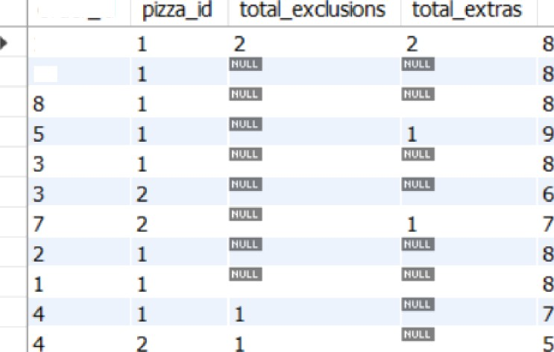

order ci

iO

I NSIGHTS GATHERED

* The most commonly ac!c!ec! extra was "Bacon”.
* The most common exclusion was "Cheese”.
* The maximum number of toppings ac!ded was nine.

1. If a Meat Lovers pizza costs $ \ 2 and Vegetarian costs $10 and there were no charges for changes - how much money has Pizza Runner mode so for if there ore no delivery fees?



l ° with total as (

2 with psi z za_detai1s a x ( select •

trom runner_orders

where cance11at 1on 1s null}

6 salect d1st1ncI ” 1f(p1zza_1d = 1, 12, 10} as pi z za_cost

from• pizza_details pd

8 joln cu stomer_orders co using(order_1d))

9 s•l•ct runner_id, sum(pizza_cost) os total_earning

16 from total

11 group fry 1

nJnner_d totd_eamrig r 1 70

### What if there was on additional $T charge for any pizza extras? o Add cheese is $1 extra

e r x a u a ‹• ••- - a < o a -

1 •- with addIt 1ona1_det at 1s as (u1th p1z za_det ai I s as (

salact

from r‘unner_orders

vhomo cancellation ir null)

select d1s t1nct * 1T(p1zza_1d = 1, 12, IO) •s pt z za_cost , c•se uhen co. extras 1s null then 0

else { 1er gt h(co. ext ras) 1- ngI I ( replace(co. ext ras, ’ , ' end as add1t i ona1_cost

Unani pt z za_det ai 1s pd

yoln cus tomer_orders co us1ng(order_id})

oslsct runner_id, sue(pizza_cost+sdditienel_cost) zc totel_cost

12 from additional_detaSls

' ' ) ) + 1}

 

|  |  |
| --- | --- |
| ”1 | 72 |
| 2 | 45 |
| 3 | 13 |

1. The Pizza Runner team now wants to odd on additional rating system that allows customers to rote their runner, how would you design a supplementary table for this new dataset - generate a schema for this new table and you con insert your own data for ratings for each successful customer order between 1 to 5.

creata vlaw runner_orders_new as (

elecC °, if(cancellation is null, floor(I + rand() ° 5), null) cs catiugs

from runner_order s j

|  |  |  |  |  |  |  |
| --- | --- | --- | --- | --- | --- | --- |
| order_d | runne id | @kup time | dBtance | duratbn | cancetaton | ratñgs |
| 1 | 1 | 2020-D1 DI 18:15:34 | 20 km | 32 mn |  | 3 |
| 2 | 1 | 2020-01-0119:t0:54 | 20km | 27mn |  | 4 |
| 3 | 1 | 2020-01-0300:12:37 | 13.4km | 20mn |  | 5 |
| 4 | 2 | 2020-01-0413:53:03 | 23.4krn | 40mn |  | 3 |
| S | 3 | 2020-01-08 21:10:57 | 10 km | 15 md |  | 3 |
| 6 | 3 |  |  |  | Reslaurant Care:e3atbn |  |
| 7 | 2 | 2020-01-08 21:30:45 | 25 km | 25 md | " | 1 |
| 8 | 2 | 2020-01-10 00:15:02 | 23.4 len | 15 mtt |  | S |
| 9 | 2 |  |  |  | Customer Caix:elation |  |
| lo | 1 | 20Z0-01-11 18:50:20 | 10 diri | l0 MPi |  | 4 |

1. If a Meat Lovers pizza was $\ 2 and a Vegetarian $10 fixed prices with no cost for extras and each runner is paid SO.30 per kilometer traveled - how muck money does Pizza Runner have left over after these deliveries?



* 1. °— with leftover as (
  2. with total as(

solmct distinct c.order_id, r.runner_id, c.pizza_id, r.distance,

1. i€(c.pizza_id : l, 12, 18) nm pizza_jprice, (r.distance"0.30) ns runner_paid

from c ustomer_orders c

josn r'unner_or'ders r' using(order_id) where cane e1 fat ion 1s nu11$

8 seEect runner_id, sum(p1zza_pr:tce) as I ota1_piz za_price, sum(r'unner_patd) as tot aL_runner aid

16 from totaL

1. group by I )
2. select runner'_ d
3. con cat "g " round {total izza r‘1ce - I ota1_r•unner aid 2} ) as 1eff_aver_maney
4. 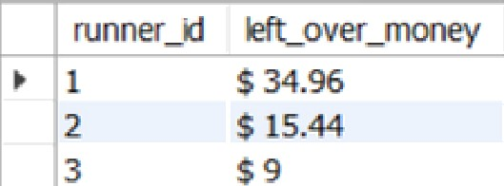fram Leftover;

|  |  |
| --- | --- |
| runner_id | ft_pver_money |
| * t | S 34.96 |
| 2 | S t5.44 |

1. Using your newly generated loble - con you join all of the information

together to form a table that has the following information for successful deliveries?

o customer id

0 order id"

0 runne id

# 0 rdnr time

0

o pickup_time

o Time between order and pickup

0 Delivery duration

0 Average speed

0 Total number of pizzas



z•on•pmcktqt_tzee,

I oncac(44••at•a6dA+ faza•t•e con•o• ier_t:Iae •p1ckx +_tSee}," •Sn") •• t1ee_d1fF_ordee_md„ptck ,

1. non.z¥zrataan •s de11vcry_durat1on round(r'on.d1stanca•6e/non.durat*om, 2) •a spaad_kaph,
2. count{*) wvar{par•t£t5on by r•on.or•dar_ad) •a tota1_no_of_p1zzas
3. ft custaaar_or'da¥'_r+am cou
4. rAgI•t 3•4•• mmner_ s_nev ron ••5ngforder_Sd}
5. uhaz•a c•r+ce12atioai fic null}

IO calact ousC _1d onder_1d ruzusar_sd r•ound{avg{rat1nga)) •a rslz1ngs

1. order_tTae p1ckzqs_t1wa txse_d1ff_or•dér_end_p1ckup
2. deIivsey_durwtion, *pe*d_W•ph, to4sl_no_of_pizzss

¥3 +-cte



¥ 101

101

102

1

2

3

¥ 1

1

B

1o

2

1

3

L 2

9

+

2

2 I•01-01tB XYZ

•0tt6:15:34 10nm

2tWI•01-0119fBXSZ Z/WMft-OF 1@¥0:H 10¥r€t

a)d0 i1-0223:S€ 3020-0£-03fXt:22:37 21o0i

20d0-III-06 21«¥X29 2020-01-IB 21:10:57

20 0-€11-09 ZZ:54M3 ZO20-01-10 CYL’.15:IIZ

a¥d0-o1-IL LB:B4c4B 2oa6oz-11 zaW•Z0

10 nEi

20 zrM

Isztñs

1s«m

EOIsOs

s

INSIGHTS GATHERED

* Pizza Runner 1 has earned $ 70 among the other two runners if there is

*no extra charge* for the extras.

* Pizza Runner 1 has earned $ 72 among the other two runners if there is

*an extra charge* for the extras.

* Pizza Runner 3 has $ 9 left after all the deliveries.

